Fall Reopening Facilities and Operations Guidance
July 22, 2020

Table of Contents

Introduction 2

Critical health and safety requirements for facilities 4

Communicating facilities-related changes 6

Facilities and operations planning checklist 7

1. Preparing spaces 8

Learning spaces 8

Staff office spaces 9

Mask break spaces 10

Medical waiting room 10

Entry and exit points 11

Recess 11

Storage and disposal 12

2. Making systems and other space use modifications 12

Handwashing and hand sanitizing stations 12

Ventilation and HVAC systems 12

Indoor spaces without windows 13

Hallways 14

Bathrooms 14

Lockers 14

Signage 14

3. Developing operational protocols 15

School cleaning and disinfecting 15

Shared items 16

Food service operations 17

Eating areas for students 17

Visitors and volunteers 20

Appendix A: Maximizing school space 21

Appendix B: Laboratory seating 28

Appendix C: Cafeteria seating 30

Introduction

As a supplement to DESE’s Initial Fall School Reopening Guidance, we are providing districts and schools with this guidance on facilities and operations for reopening this fall.

As stated in our Initial Fall Reopening Guidance, our goal is to promote the safe in-person return of as many students as possible in a school setting. For students and staff to return to school, schools and districts will need to prepare their facilities and adapt operating procedures to adhere to medically-advised health and safety requirements. Additionally, districts should follow federal, state, and local safety requirements applicable to school buildings.

As we continually review the medical and science literature, various reports and articles, and information from the Centers for Disease Control (CDC), World Health Organization (WHO), and other countries and states, it is clear that it is not a single action, but the combination of actions that minimize risk, mitigate the virus’s transmission, and help create safe environments.

This Facilities and Operations Guidance provides additional details and considerations for school facilities and grounds, as well as operational protocols based on the most recent information we have about COVID-19 and related mitigation practices. As the knowledge and research related to COVID-19 continues to evolve, this Facilities and Operations Guidance will be updated as appropriate.

This guidance begins with a summary of the critical health and safety requirements, followed by communications guidance. It then provides information in three main sections, followed by examples of classroom, lab, and other space planning diagrams. The three sections are:

- Preparing spaces,
- Making systems and other space-use modifications, and
- Developing operational protocols

Support for schools and districts

To support districts and schools in implementing this Facilities and Operations Guidance, DESE is providing the following assistance:

Financial resources:

To date, the following federal grants have been available to cities and towns for educational expenses related to COVID-19:
- $193.8 million from the Elementary and Secondary School Emergency Relief (ESSER) Fund to districts, largely based on the Title I formula.
- A portion of the $502 million from the Coronavirus Relief Fund (CvRF) already allocated to cities and towns

In addition to the above funds, the Commonwealth is making available:

- $202 million from the CvRF to support school reopening. Of the $202 million, $182 million will be formula grants ($225 per pupil), and $20 million will be available at the Commissioner’s discretion for distribution to districts with unmet needs.
- $25 million available for remote learning technology grants to match local amounts that districts plan to spend by the beginning of the school year.

While school and district budgets remain uncertain, these additional resources will help schools and districts provide a healthy and safe environment for in-person learning in the fall.

Technical assistance, including with ventilation/HVAC systems:

For help with general questions about the information in this Facilities and Operations Guidance, please contact:

- Russell Johnston: Senior Associate Commissioner, Russell.Johnston@mass.gov, 781-605-4958
- Erin McMahon: Fall Reopening Implementation Lead, Erin.K.Mcmahon@mass.gov, 781-873-9023
For help with questions about ventilation and HVAC systems, please contact: Matt Deninger, Acting Chief Strategy and Research Officer, at Matthew.J.Deninger@mass.gov or 781-338-3117.

Waivers for student learning time requirements:

For changes in scheduling related to the use of spaces, including staggered schedules and mealtime scheduling, schools and districts may require flexibilities with student learning time requirements in order to enable more students to return to school in-person. If so, districts should contact Russell Johnston (russell.johnston@mass.gov) or Erin McMahon (erin.k.mcmahon@mass.gov) to request a waiver from student learning time requirements. More information on waiver requests will be forthcoming.

Critical health and safety requirements for facilities

Developed in consultation with pediatricians, infectious disease physicians, other medical advisers, and the COVID-19 Command Center’s Medical Advisory Board, and including a review of CDC and WHO guidance, the health and safety standards and requirements below will enable students and staff to safely return to school this fall. These requirements will need to be supported by adjustments to how school facilities are used and how they operate. More details on implementation practices and considerations follow in this document.
- Masks: Masks are one of the most important tools to prevent transmission of the virus. From a facilities and operations perspective, it is important to consider how to best support adherence to masking, including putting up signs with reminders to wear masks and how to remove them safely, having a supply of masks for staff and students who may need them, safely disposing of soiled or unusable masks, and identifying spaces that are appropriate for mask breaks. Masks covering the nose and mouth are to be worn by students (required for grade 2 students and up and strongly encouraged for kindergarten and grade 1), staff, visitors, and vendors. Exceptions for meals, mask breaks, and medical exemptions are permitted.

- Handwashing and hand sanitizing: Enabling good hand hygiene practices is another key tool to mitigate transmission of the virus. From a facilities and operations perspective, enabling good hand hygiene practices spans from student and staff arrival at school until their departure. This includes providing handwashing or sanitizing stations (touchless if feasible) in commonly used areas (e.g., entries and exits, classrooms, bathrooms, eating areas, stairwell exits, etc.), ensuring sufficient supplies to accommodate frequent hand washing, and having hand sanitizer readily accessible.

- Physical distancing: Physical distancing is a critical component in mitigating the transmission of the virus. Schools should aim for a physical distance of 6 feet when feasible; 3 feet is the minimum distance allowed. During meals, mask breaks, and other times when masks are not worn, 6 feet is the minimum distance allowed. From a facilities and operations perspective, it is important to understand how these minimum requirements will affect space layouts and movement protocols.

- Creating cohorts wherever possible: Directly related to physical distancing is the idea of creating cohorts (e.g. self-contained groups) of students wherever possible and limiting the cohort from interaction with others. Examples of cohorts could include an elementary school class, students on a bus, or groups of older students with similar schedules. By grouping students and staff into cohorts, interaction will be limited. This means that if there is a positive COVID-19 case in the school, fewer individuals will have interacted with that person. Cohorts should be used to the extent feasible for classes, transportation, mask breaks, meals, recess, and extra-curriculars. To assist with establishing cohorts, all students should have assigned seating in each class and to the extent feasible for meals and other activities. Washable mats could be used for early elementary and preschool students to define individual spaces for children.

- School cleaning and disinfecting: From a facilities perspective, schools should update cleaning and disinfecting protocols, obtain additional supplies, and train staff appropriately. Cleaning and disinfecting should occur at least daily for shared spaces and furniture. For high-touch surfaces (e.g., door handles, light switches, handrails), cleaning and disinfecting should occur multiple times per day between uses.

- Ventilation: Schools should work to increase outdoor air ventilation instead of using recirculated air and increase air filtration as much as possible for the ventilation and filtration system.

- Movement protocols within facilities: Develop clear movement protocols to avoid crowding, maintain cohorts, and minimize unnecessary person-to-person interactions. These protocols should include a plan for arrival and dismissal times, transitions between classes, and bathroom breaks, as well as outlining one-way movement pathways for hallways and cafeterias.

Communicating facilities-related changes

Schools should develop a comprehensive approach to communications with educators, staff, students, families, and other community members.
While strong communication is always important, the ever-changing circumstances related to COVID-19 make an effective, multi-faceted communication plan essential to districts. We have highlighted some initial communication topics below for facilities, but each district should identify additional topics as needed:
- Summary of major facility changes (e.g., installation of additional handwashing and hand sanitizing stations, installation of barriers, configuration of classroom desks) to promote a healthy and safe return to school
- Guidance for health and safety protocols expected from students and staff (e.g., frequent handwashing, maintaining physical distance, following one-way directions in hallways, limiting use of bathrooms during high-traffic periods etc.). Create and use visual cues and posters to communicate, especially with younger students.
- Food services and distribution changes to emphasize individually packaged foods and use of disposable cups or water bottles, as well as changes in remote meal offerings from spring and summer programs
- Visitor protocols for parents and guardians
- Arrival and dismissal protocols related to pick-up and drop-off
- Medical waiting room procedures in case a student experiences COVID-19 symptoms

Informing students, families, and staff to ensure alignment and adherence to guidance

Districts should develop a series of information sessions for staff, students, and families to share information on new school protocols and roles and responsibilities and to answer questions. . To help with the development of this information, DESE will provide reference materials and examples as we are able, including some best practice examples. Below, we have highlighted some initial topics that should be shared:
- All health and safety protocols (e.g., wearing masks, hand hygiene, shared items, transitions, medical waiting room)
- Proper use of masks and other PPE
- Facility operations changes, including hallway movement, locker use
- Proper cleaning and disinfecting procedures
- Food services and distribution procedures
- Arrival and dismissal procedures

Facilities and operations planning checklist

Each district and school should develop a facilities and operations plan to ensure effective implementation of health and safety guidance. This plan should include the following key areas:

- Prepare spaces in the facilities: Develop plans to prepare the following spaces prior to the start of the school year.
  - Student learning spaces
  - Staff office set-up
  - Mask break spaces
  - Student eating areas
  - Medical waiting room
  - Entry and exit points
  - Storage and disposal of unnecessary furniture or other items
- Make modifications to facilities and building systems as feasible: Develop plans to ensure set-up of additional fixtures and appropriate modifications to the existing physical infrastructure.
  - Handwashing and hand sanitizing stations
  - Ventilation and HVAC systems
  - Hallways
  - Bathrooms
  - Water fountains
  - Lockers
  - Signage throughout the building
- Develop operational protocols: Develop operations plans to align all staff, families, students, and visitors on expected healthy behaviors and precautions.
  - Cleaning and disinfecting
  - Food preparation and distribution
  - Movement in the facility
  - Arrival and dismissal of students
  - Sharing items
  - Visitor and volunteer engagement
  - Using the medical waiting room
- Develop communication protocols
- Inform students, families, staff, and visitors to ensure alignment and adherence to guidance

Preparing spaces

Learning spaces
We acknowledge that districts and schools face individual constraints and each school building presents unique features and layouts (i.e., furniture, storage, classroom size and shape). To inform this guidance, we conducted classroom visits and set up model classrooms to derive options for districts to consider. Further examples and details are in Appendix A.

- Space inventory: Create a list of all classrooms, large spaces (such as auditoriums or libraries), and additional spaces that could be used for student activities, including outdoor areas, certain corridors, etc.
- Measure spaces: Know the dimensions of each space. If available, obtain building plans to understand square footage. These plans might be available from your district offices or the architectural and engineering firms that worked on the building. If the dimensions are not available on the building plans or if those are difficult to work with, you may need to manually measure spaces. This will only have to be done once for those classrooms and spaces that are the same size and can help with assessing different space use variations.
- Clear spaces: Clear classrooms and other spaces in the school building (auditorium, library, etc.) of any non-essential items or furniture to maximize available space. Keep only what is truly essential in each room, as every additional item that remains could displace a student. As it is recommended to limit shared items or supplies between individuals, consider what items may no longer be used in the class and what items may now need to be available on an individual basis.
- Outdoor spaces: As feasible, consider the use of outdoor spaces for classes, breaks, meals, and other activities. Some jurisdictions have considered tents, platforms, and other not-permanent structures in spaces adjacent to buildings, such as courtyards, play areas and parking lots.
- ‘Off campus’ spaces: Review community and municipal spaces with local stakeholders to determine if other buildings are available to provide additional classroom space.
- Design to maximize space: Map out each space to optimize for student learning, based on the sample diagrams and parametric tool in Appendix A. The medically-advised minimum distance allowed is 3 feet from seat edge to seat edge. Desks should face in the same direction. There is no maximum number for group size, so long as schools adhere to the physical distancing requirements. Six feet of physical distance is required when people are not wearing masks (e.g. eating or mask breaks). All students should have assigned seating in each class and, to the extent feasible, for eating, mask breaks, and other activities.
- Reconfigure spaces: Consider using temporary walls or dividers to break up large areas into smaller classrooms, separate cohorts for meals, or structure other activities. In elementary and preschool classrooms, the classroom and “stations” can be set up to create natural physical distancing. Some jurisdictions are considering installing temporary floor-to-ceiling walls to maximize cohorts in larger spaces. Be mindful that temporary barriers may not block sound as well as permanent walls.
- Fire code and safety: Throughout planning, schools and districts should be aware of their fire code and building safety guidelines as they work to maximize space within buildings. Ensure that desks are not blocking means of egress in the event of an emergency and that desks are adequately spaced from radiators or other heating or cooling elements. Avoid obstructing means of egress if you are storing items in hallways. If appropriate, consider propping open doors to improve air circulation and reduce the number of times people touch door handles.

Plexiglass barriers: There are pros and cons to the use of plexiglass barriers. In general, we do not recommend setting up plexiglass barriers in regular classrooms, since they represent an additional high-risk surface to clean and disinfect. However, barrier use is permitted if classroom furniture cannot be replaced and if required physical distancing cannot be achieved without the use of barriers, such as in shared table or laboratory settings where there is limited capacity and desks are often heavy or immovable. Additional considerations for barrier use in laboratory spaces can be found in Appendix B.

Considerations for early childhood and younger elementary classrooms:
- Remove all soft and cloth-based materials, such as rugs, pillows, stuffed animals, and dress-up clothing. Children can bring their own stuffed animal, but it cannot be shared.
- In lieu of forcing young children to sit continuously at desks, consider making laminated mats with children’s pictures. Washable mats, plastic trays, and other items which can be easily cleaned can be used to define space for each student.
- Learning centers: Instead of having different small groups of children (three to four, depending on space available) rotate among different learning spaces as they engage in different activities, consider having each small cohort remain in one location and have materials for the next “center” brought to them.
- Marking spaces: Consider marking spaces with footprints facing the correct direction the children’s feet would be pointing to indicate one way in and one way out.

Staff office spaces
- Reconfigure spaces: Rearrange furniture to support physical distancing, with staff desks facing in the same direction when possible.
- Staff break rooms: Rearrange furniture to support physical distancing and consider adjusting staff schedules to limit the number of individuals in the room at one time.

Barrier use: Consider setting up barriers (e.g., plexiglass shielding) in high traffic areas or areas where physical distancing between staff cannot be achieved. Design the cleaning schedule to ensure proper cleaning and disinfecting of barriers by custodial staff.

Spaces for mask breaks
- Purpose: It is recommended that students have at least two mask breaks per day (e.g. mealtime and recess). If additional mask breaks are scheduled, identify what spaces (ideally outdoors) will be used.
- Requirements: Spaces for mask breaks must allow students to be at least 6 feet apart. Consider using tape or other markers to identify where students should be to maintain 6 feet of separation. Hand washing facilities or hand sanitizer must be available upon entering and leaving this space. Provide napkins or paper towels for masks to be set on (inside face up) when removed. Consider adding signage in mask break areas on how to properly put on and take off masks. As mask wearing is recommended for children younger than second grade, it is important to note that these students may need additional mask breaks during the day.

Medical waiting room
- Purpose: This is a separate space from the nurse’s office or the regular space for providing medical care. It may be located near a nurse’s or other health related office. The medical waiting room will be used when a student presenting COVID-19 symptoms needs to be separated. From a facilities perspective, every effort should be made to find a self-contained space, ideally near an exit/entrance and with a dedicated bathroom.
- Staffing: When occupied, the medical waiting room should always be monitored by appropriate staff.
- Masks required: Masks are always strictly required in this space, even for students in kindergarten and grade 1. The individual supervising this space must always maintain 6 feet of physical distance, remain masked, and wear a face shield or goggles. Be sure to have face shields or appropriate goggles available to staff. Personal protective equipment guidance recommends that nurses or other staff in this area be equipped with N-95 masks. If a student is unable to wear a mask, there should be no other students in this room.
- Hand hygiene: Hand washing facilities or hand sanitizer needs to be used when entering and leaving the space, as well as before and after eating.
- Food/drink: If any food or drink must be consumed before the student is picked up, the individual should be walked outside to consume food or drink if possible (because mask will have to be taken off for eating). If not possible to go outside, one student can consume food or drink at a time in the medical waiting room, but, again, only if all others remain at least 6 feet away.
- Ventilation: When possible, this space should have windows that open and exhaust directly into the outdoors. Depending upon the facility, other options should be explored to increase ventilation to this area and/or otherwise improve the air filtration.
- Size: This space should be large enough to accommodate several individuals at least 6 feet apart. All people in the COVID-19 waiting room must be as far apart as possible and no less than 6 feet apart, even when masked.

Entry and exit points
- Arrival to school:
  - Prioritize overall safety considerations, (e.g. child welfare, preventing intruders and weapons) in planning school arrival/exit.
  - As practical, consider assigning multiple entry points or staggering arrival times to avoid crowding in entry areas.
  - Post appropriate signage and reminders about the health and safety requirements that everyone needs to follow.
  - Ensure hand washing or sanitization is available upon entry, as well as appropriate disposal containers.
  - Ensure that all students, staff, and visitors, with noted exceptions for medical needs, are wearing masks covering their nose and mouth.
  - Ensure that additional masks are available at the entry as may be necessary.
  - Consider having staff monitor entry to ensure everyone properly disinfects their hands and is wearing masks.
  - While there are no screening procedures required at the point of entry, school staff should observe students throughout the day and refer students who may be symptomatic to the school healthcare point of contact.
- Limit contact with doors: If allowed by school safety guidelines, consider keeping doors propped open during entry/exit times if constantly monitored. Consider installing touchless doors as feasible.
- Dismissal from school: Consider designating multiple exit points, staggering dismissal times, and monitoring handwashing or hand sanitization upon exit. Before students are dismissed, confirm they have gathered all personal belongings before leaving, especially those that require cleaning at home. Additional details on pick-up and drop-off protocols can be found in the Transportation Guidance.

Recess
- Hand hygiene: Hand washing facilities or hand sanitizer needs to be used upon entering and leaving recess space.
- Cohorting: Consider designating outdoor spaces to separate cohorts and support physical distancing while still providing recess opportunities.
- Cleaning and disinfecting: When possible, clean and disinfect high-touch surfaces made of plastic or metal between cohort use.
- Masking: If students are outdoors and maintain a distance of at least 6 feet, consider using recess as an unmasked time. Otherwise, monitor for adherence to masking requirements and at least 3 feet of distancing.
- Activities: Playgrounds can be used with staff monitoring to ensure physical distancing and masking. Consider whether the number of staff at recess will need to be increased. Additional staff may be needed during high-risk times (the beginning and end of recess) and in high-risk locations (enclosed or small, hard-to-see places on fixed equipment, or anywhere with high child density).

Storage and disposal
- Storage of furniture and other items: Given the critical need for space and in order to move furniture and non-essential items, districts may need to use storage pods or other spaces in the community. Districts could also consider renting storage space temporarily.
- Storage for cleaning supplies: Adequate storage space should be allocated for cleaning supplies and disinfectants, and it should be accessible only to staff. More information on storing cleaning supplies and disinfectants is available in this EPA resource.

2. Making systems and other space use modifications

Handwashing and hand sanitizing stations
Handwashing removes pathogens from the surface of the hands. While handwashing with soap and water is the best option, alcohol-based hand sanitizer (at least 60 percent ethanol or at least 70 percent isopropanol) may be utilized when handwashing is not available.

Provide handwashing or hand sanitizing stations in the following common areas and ensure there are enough supplies (soap and sanitizer) at all times to accommodate frequent hand washing and sanitizing:
- All entries and exits
- In bathrooms
- In classrooms
- In libraries and shared activity spaces
- Next to meal distribution and consumption areas
- Next to water fountains that require touch to operate
- Next to mask break areas (if additional mask break areas are identified)
Given the importance of maximizing handwashing and sanitization stations, it may be permissible to have students within 3 feet of distance for a brief period of time (20 seconds) during hand washing as long as masks are worn and students are not directly facing one another. This will permit all sinks in a bathroom to be used even if closer than 3 feet apart, for example.

Ventilation and HVAC systems

Appropriate mask usage remains the best defense against all forms of respiratory transmission. Schools can further mitigate airborne transmission by increasing outdoor air ventilation or filtering air that is recirculating within a room or building. From a facilities and operations perspective, it is important to determine the best approach for each school site given differences in ventilation capabilities.
While there have been many schools built over the past decade with similar building plans and operating systems, most schools have different ventilation and HVAC systems and capabilities. From a facilities perspective, this means it is important to understand the opportunities and challenges unique to your building.
- For buildings that have facility-wide HVAC systems, it is likely that you will also have a contact or contract with experts to help maximize ventilation and filtration.
- For other buildings, this guidance is meant to provide you with direction and to answer key questions.
- If you have specific questions about ventilation and HVAC, please contact Matt Deninger at Matthew.J.Deninger@mass.gov or 781-338-3117.

Prepare ventilation systems
- Clean ventilation system: Ensure the school ventilation system is properly cleaned.
- Run HVAC systems: Operate HVAC systems with outside air dampers open for a minimum period of one week prior to reopening schools.
- Consider upgrading filters: In buildings with mechanical ventilation systems, consider upgrading filters to increased efficiency ratings. Schools that are not able to upgrade filters may explore alternative ways to improve ventilation (e.g., through open windows), if appropriate for their system.
Increase outdoor air ventilation
- Adjust HVAC settings: Some mechanical ventilation systems can forcibly bring outdoor air inside and then distribute that fresh air to different areas of the building. If possible with the site’s HVAC system, adjust settings to increase the flow of outdoor air. If your system can do this, evaluate the impact of adjusting windows or doors manually, as they may negatively impact the system itself.
- Open windows or doors (when appropriate and safe): For facilities without the above HVAC capability, evaluate the options to open windows and doors when safe to do so, as well as the feasibility of increasing outdoor air intake with fan boxes in windows.
- Prevent or minimize air recirculation: Facilities staff should evaluate how to eliminate or minimize air recirculation in their HVAC systems to the extent possible.
- Maintain ventilation for longer hours: If possible, schools should leave ventilation systems running longer than normal. Ideally, ventilation systems would run continuously, but it is recommended they run at least two hours before and after school, as there may still be individuals in the building (students or staff).
Indoor spaces without windows
- For any spaces without windows that may be used for student activities, special attention must be made to ensure that there are adequate HVAC capabilities for the space.
- Otherwise, indoor spaces without windows and adequate HVAC should not be used or only used as may be appropriate for storage or similar uses.

Hallways
- Create standard routes: Outline a plan for hallway use to minimize congestion. When possible, make hallways one-directional to prevent students from directly passing each other. This is especially important for small hallways. Ensure that stairwells are also properly marked and one-directional. Staff should reinforce these directions, adherence to physical distancing, and masking. Schools should test emergency evacuation protocols and carefully communicate any relevant changes.
- Close off certain hallways: Consider closing off hallways or areas that are too narrow for proper physical distancing and unable to be one-directional.
- Stagger class transitions: Develop a plan for transitions between classes to avoid crowding in hallways. Consider dismissing students grade-by-grade or according to other cohort models. Consider identifying facility monitors or class monitors to ensure students wear masks, maintain distance, and do not linger in the hallway.

Bathrooms
- Hand dryers: Consider replacing hand dryers with disposable towels, as hand dryers increase the flow of air particles in the bathroom.
- Touchless technology: Place a trash can and paper towels by the bathroom door to allow students and staff to avoid touching door handles directly. If possible, consider installing touchless technology in the bathroom equipment (e.g. hand soap, paper towel dispensers, automatic doors).
- Ventilation: When feasible, open windows in bathrooms that do not pose a safety or privacy risk and if not against HVAC system standards.
- Bathroom use: Consider not allowing students to use the bathroom during transition times, and otherwise using a bathroom sign out system to reduce the number of students in bathrooms at one time. Ensure that students use their own writing instruments for the sign out log.

Lockers
- Limit usage: Consider suspending the use of lockers. If lockers are needed, stagger access times and monitor students for masking and physical distancing.
- Shared lockers: Sharing lockers is not recommended but is allowed if access can be staggered and there is a minimum of 3 feet separating the lockers used at one time.

Signage
Ensure clear and age-appropriate signage is posted in highly visible locations throughout school property, reminding students and staff to follow proper health and safety protocols. Example signage on how to wear masks and reminders to wash hands are provided by both the DPH and CDC. Signage should be translated into a language understood by each student. Signage should be posted in the following key areas (non-exhaustive):
- By handwashing and hand sanitizing stations: To remind individuals of the proper way to clean and sanitize hands
- In bathrooms: To remind individuals to properly clean and sanitize hands, utilize no-touch solutions as much as possible
- By entry/exits: To remind students to wear masks and maintain physical distance
- By eating areas: Use markers to map out entry/exit flow for students, to space out lines for students picking up their meals, and to identify distancing between students as they eat. Post signs to remind students to avoid sharing food, utensils, and drinks
- By mask break areas: To remind individuals to maintain 6 feet of physical distance and to follow correct mask removal procedure
- In classrooms: To remind individuals of physical distancing, reduce sharing of items, and keep masks on
- Around playgrounds: To encourage physical distancing while outside and maintain cleaning and disinfecting of high-touch areas
- In hallways: Use well-marked lines on the floor to encourage physical distancing and indicate direction of travel, especially in small hallways. Include signage to encourage healthy behaviors (e.g., wearing of masks)
- Next to frequently shared equipment: Post signs to remind students and staff to wipe down frequently shared equipment (e.g., computers and keyboards) before and after use
- Areas where queueing may occur: Use well-marked lines on the floor to encourage physical distancing
- By closed areas: Mark off closed areas

3. Developing operational protocols

School cleaning and disinfecting
Although it is not the main way the virus spreads, it may be possible for an individual to get COVID-19 by touching an object that is contaminated and then touching their own mouth, nose or possibly eyes. Ensure facilities are properly cleaned and disinfected each day following the guidelines below:

- Frequency: Cleaning and disinfecting should occur at least daily for shared spaces and furniture. For high-touch surfaces (e.g., door handles, light switches, water fountains, toilet seats) cleaning and disinfecting should occur three to four times per day and/or between uses.
  - Desks: Desks should be cleaned at least daily. For situations when cohorts of students move between classrooms or where meals are eaten at desks, cleaning of desks must take place between classes and before and after meals. Cleaning of desks can be done by students or custodial staff. Carefully choose disinfectant solutions that require a short dwell or drying time and are appropriate with food surfaces.
  - Electronics: Consider putting a flat, wipeable cover on electronics that are difficult to clean (e.g., keyboards). Follow manufacturer’s instruction to determine the appropriate disinfectant solution and how to properly clean and disinfect. If there is no guidance, use alcohol-based wipes or sprays containing at least 60 percent ethanol or 70 percent isopropanol. If shared, electronics must be cleaned between use by students or custodial staff.
  - Outdoor play areas: High-touch surfaces made of plastic or metal should be cleaned and disinfected at least daily or between use by custodial staff.
- Responsibility: Dedicated custodial staff should handle all disinfection requiring chemicals for facilities (e.g., classrooms, bathrooms, mask break areas) and high-touch objects (e.g., door handles, light switches, water fountains). For other surfaces, determine cleaning responsibility on a case-by-case basis. For shared and high-touch items such as desks, cleaning responsibility may be shared by students, if the task is age appropriate and safe.
- Disinfectant solutions: To select the proper disinfectant, review the suggested list on the EPA website. Consider using an alcohol solution with at least 60 percent ethanol or 70 percent isopropanol, a diluted bleach solution (if prepared daily to ensure efficacy), or an EPA-approved disinfectant unless otherwise instructed by the manufacturer’s instructions. When selecting a disinfectant solution, consider the dwell time, which surfaces are used as eating surfaces, and the potential risk of triggering asthma symptoms for sensitive individuals.
- Mask disposal: If a reusable mask breaks and needs to be thrown out or if a single-use mask needs to be disposed of, it should be placed into the nearest trash can by the individual who wore the mask. The individual should immediately put on a new mask after washing their hands.
Shared items
- Limit sharing: Sharing materials is discouraged, but when shared, they must be cleaned before being used by other students.
  - To the extent possible, limit sharing of electronic devices, toys, games, learning aids, art material and other items that are difficult to clean or disinfect. Limit the use of supplies and equipment to one group of children at a time, and clean and disinfect items between uses.
  - Library books may be checked out if students clean their hands before and after use and if students only select books from the shelves, instead of the return area. Books and other paper-based materials are not considered a high risk for transmission and do not need additional cleaning procedures.
  - Identify and develop new classroom protocols that reduce passing supplies or items between students.
- Hand hygiene: Frequent hand washing or sanitizing, including before and after using shared materials, is an important control strategy that should be reinforced when objects and materials will be shared.
- Purchase additional items: Consider what supplies might need to be available on an individual basis, and purchase additional items to minimize sharing (e.g., assigning each student their own art supplies), as feasible.
- Storage: Keep each student’s belongings separated from others’ and in individually labeled containers, cubbies, or areas. Similar to locker usage, make sure to stagger access to these areas to maintain physical distancing if used. Additional guidance on sharing protocols is forthcoming.
Food service operations

Eating areas for students: As students will be unmasked to eat, there is a strict requirement of 6 feet of physical distance between each student. Based on current CDC recommendations, it is preferable for students to eat in classroom spaces. This may not be feasible for all sites, given classroom sizes, room scheduling, and physical distancing requirements. Schools may need to explore alternative options for students to eat their meals. Our prioritized recommendation includes the following options.
- Eating in the classroom: Based on CDC recommendations, it is preferable for students to eat in classroom spaces. Meals can be delivered to classrooms, or students can bring food back from the cafeteria to eat. Schools may consider having half of the class take an outdoor mask break or recess time while the other half eats and then switching these groups to enable 6 feet of distancing. Additional staff may be needed to supervise, as the students are in two separate spaces in this model. The desks and other surfaces that students are using for meals should be cleaned between groups. Cleaning includes using an approved EPA disinfectant on these surfaces and then appropriately disposing of the materials used to wipe down the surfaces. Custodial staff or students may perform this surface cleaning, if appropriate.
- Eating in the cafeteria: If a single large lunchroom is to be used for eating (and is not utilized for classroom space), clearly mark spaces where cohorts and students can sit. Students must maintain 6 feet of distance when unmasked unless plexiglass barriers are used to separate students. Ensure that students do not mingle with other cohorts. The tables and other surfaces that students are using for meals should be cleaned between groups. Cleaning includes using an approved EPA disinfectant and then appropriately disposing of the materials used to wipe down the surfaces. Custodial staff or students may perform this surface cleaning, if appropriate. Please refer to Appendix C for further details and considerations on utilizing cafeteria space.
- Eating in alternative spaces: Outdoor meal consumption can be an effective way to ensure physical distancing, weather permitting. Consider other available spaces as well that will not obstruct egress or create other fire code issues. For example, use of hallways for mealtime may be possible depending on hallway width. Half of the students could eat their lunch in the classroom, with strict 6 foot distancing in place. The other half could eat in the hallway on benches or chairs, with 6 feet of distance between each student. The benches and other surfaces that students are using for meals should be cleaned between groups. Cleaning includes using an approved EPA disinfectant and then appropriately disposing of the materials used to wipe down the surfaces. Custodial staff or students may perform this surface cleaning, if appropriate.

Food preparation and serving space and related protocols
- Evaluate kitchen workstations: Modify stations for physical distancing. If the kitchen is small, consider moving workstations into larger areas. Face workstations in the same direction or against the wall.
- Stagger service staff: For large food service staff, consider having the staff work in cohort-based schedules to reduce opportunities for transmission.
- Ensure food continuity: Consider methods for ensuring continuity of food service operations if food service staff become sick. This could include setting up coverage from other schools within the district or purchasing a supply of shelf-stable meals.
- Receiving deliveries: Work with kitchen staff and vendors to determine safer ways to handle deliveries given COVID-19 considerations. Mark entrances where deliveries will be handled, and schedule deliveries in a way that reduces crowding. If the vendor plans to drop deliveries outside and reduce the number of visitors inside the building, consider investing in dollies or assisting kitchen staff with moving deliveries to avoid workplace injuries.
- Ensure food safety training: Ensure that food service staff and substitutes have food safety training. Review current food safety plans and revise as needed. Free web-based food safety resources include:
  - John Stalker Institute Food Allergy Resources
  - Breakfast in the Classroom operational and safety protocols
  - School Food Service Safety Precautions for School Nutrition Professionals
  - Massachusetts Food Safety and Education Safe Bag Lunches:
  - CDC Food and Coronavirus

Preparation and distribution
- Health and safety requirements: Adjust food preparation and service procedures to minimize shared items (i.e. serving utensils), maintain physical distance, and comply with health and safety regulations. Detailed guidance on safe food preparation can be found in Massachusetts’ Safety Standards and Checklist: Restaurants.
- Individually packaged meals: Adjust food offerings to provide individually packaged, to-go style lunches, instead of buffet style served directly to students. Consider developing non-contact pre-payment systems for schools when offering individually packaged meals, if feasible. Consider establishing incentives for prepayment of meals.
- Schedule and distribution: Establish a meal serving schedule and distribution process that limits interactions between classrooms and contamination of food items or meal distribution areas. For instance, schools may schedule classroom deliveries or set times for each classroom to pick up their meals from a central location. Meal distribution should limit high-touch surfaces and exclude buffet style serving. If meals are delivered to the classroom, consider how students can pre-order meals to ensure the correct number of meals are delivered to the class each day. Consider how to return meal service materials (i.e. carts, trays) to a central location each day.
- Special dietary accommodations: Ensure new menus offer meal accommodations for special dietary needs. Ensure these meals are clearly marked and transported without risk for cross-contamination to alternative points of service. Communicate special dietary accommodations to staff distributing meals to ensure student safety and privacy.
- Non-essential food distribution: Consider closing non-essential food distribution, such as school stores or vending machines to limit eating or food preparation outside of set breakfast and lunch times. Discontinue the use of any self-service food or beverage distribution in the cafeteria.

Meal consumption
- Masks: Ensure proper removal and placement of masks before eating. Masks should be removed by handing the ties or back/ear areas of the mask once seated. Do not touch the outside or inside of the part covering the face. While eating, masks should be placed on a napkin, paper towel, or other container on the table, with the inside of the mask facing up. Masks should be put back on before leaving the seat. More information is available here.
- Distancing: Individuals must be at least 6 feet apart at all times when masks are removed.
- Hand hygiene: Individuals must properly wash or sanitize hands before and after eating.
- Water fountain usage: Schools must provide potable water to students during mealtimes. Touchless or motion activated fountains are preferred for reusable water bottles, but other fountains, water jugs, or coolers can be used with single-use cups if students wash hands or use hand sanitizer before and after fountain use. Water fountains cannot be used for direct consumption. High-touch surfaces on water fountains, jugs or coolers should be cleaned multiple times a day. Schools may also consider providing disposable water bottles during mealtimes.
- Food allergies: Stay informed of student needs, including food allergies or any needed feeding assistance to enable safe meal service and clean up.
- Food waste removal: Work with nutrition and facilities staff to determine protocols for waste management. Additional garbage cans may be needed to accommodate food waste, especially if classroom spaces are used for meals. Consider how normal cleaning procedures and schedules may be affected by new processes. Consider how students can support clean-up, such as cleaning their own eating area after the meal, if age appropriate and safe to do so.

Meals for remote learners: Schools must continue to offer meals to eligible students who are learning remotely from home. Begin planning how to operate lunch, breakfast, and/or snack programs (as applicable) for students who will not be attending in-person school five days a week. Additional guidance will be provided by DESE’s Office for Food and Nutrition Programs.

- Communication: Communicate with families on how remote meal processes will be different from this past spring.
- Delivery Methods: Begin planning for drive-through, delivery, curb-side pick-up, or end of school day take-home meals (as appropriate) for students who are not attending in-person school five days a week. Meal distribution methods utilized this past spring, including parent pick-up, can be continued, including providing meals to cover multiple days.

Visitors and volunteers
- Reduce outside visitors or volunteers: No outside visitors and volunteers are recommended, except for contracted service providers for the purpose of special education, required support services, or program monitoring as authorized by the school or district. Assign a staff member to enforce this protocol.
- Single entry/exit: Designate a single entry and exit point for all visitors and volunteers to be visually screened and logged in. For visitors who need to enter, they should first gain approval, be briefed on school COVID-19 policies, and verify they do not have symptoms. Ensure that these individuals all are wearing masks covering their nose and mouth at all times and are aware of any other health and safety protocols for the school.
- Track visitor log: A log of all visitors must be kept and maintained for 30 days, with the date, contact phone number, arrival/departure times, and areas visited within the building for each visit.
- Minimize parent/family visits and require them to occur only in the school office and/or outside spaces, if appropriate.
  - Visitors necessary for drop off or pick up must wear masks.
  - Schools should encourage only one guardian to visit a building when possible and continue to utilize virtual communication options with families (e.g., for parent-teacher conferences).
  - It is recommended that the same adult drop off and pick up the child each day if it necessary that they enter the building.
- Restrict visitor time: Schools can also consider restricting visitor access to limited times when classes are in session (i.e., at times when there will not be many people in the hallways).

Appendix A: Maximizing school space

The diagrams below outline best practices for classroom setup in order to maximize capacity while adhering to health and safety requirements. We have included sample classroom diagrams, based on common desk dimensions and several classroom tours, that outline important considerations such as health and safety codes, teacher movement, and immovable furniture or equipment. We encourage schools to physically measure each classroom in addition to using this parametric tool to make sure that space is being maximized to the extent possible.

Best Practices for Classroom Setup:
- Physical distancing: With masks, 3 feet is the minimum physical distancing. For planning purposes, this distance refers to the distance between seat edges. Spaces where masks are not worn (e.g. eating and mask break areas), 6 feet is the minimum physical distancing.
- Teacher space: Allow adequate space for teachers to ensure safe physical distance from students.
- Furniture: Consider removing non-essential furniture from classrooms. Explore storage options in advance.
- Communal areas: Consider repurposing communal areas for additional classrooms.
- Other constraints: When estimating capacity, consider additional constraints that reduce usable desk space (e.g., emergency fire egress, radiators, immovable furniture, desk/furniture size and type, camera angles for synchronous learning).

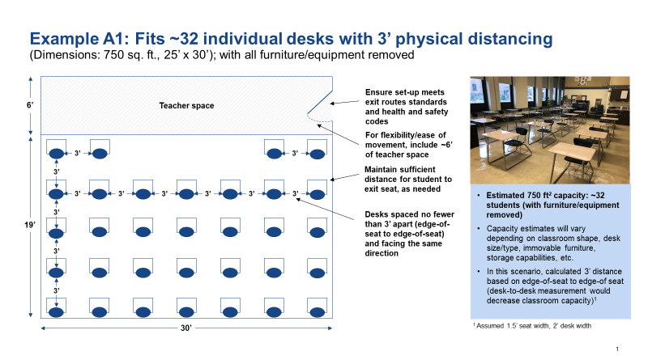
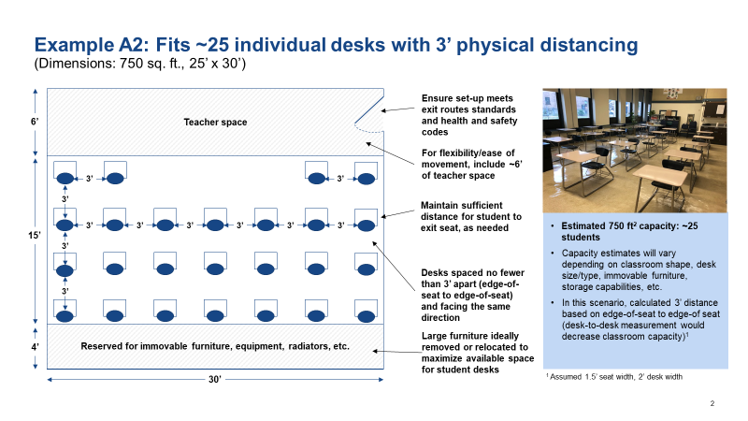
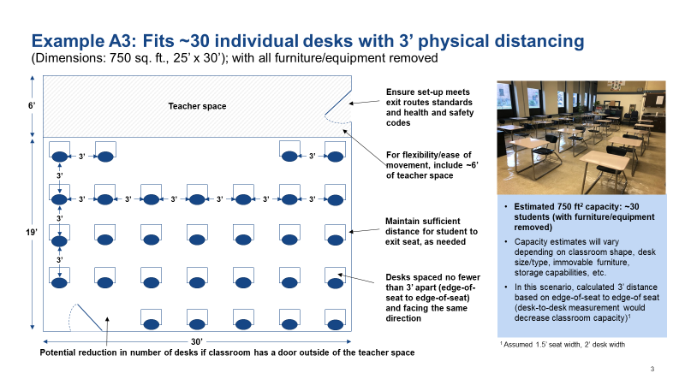

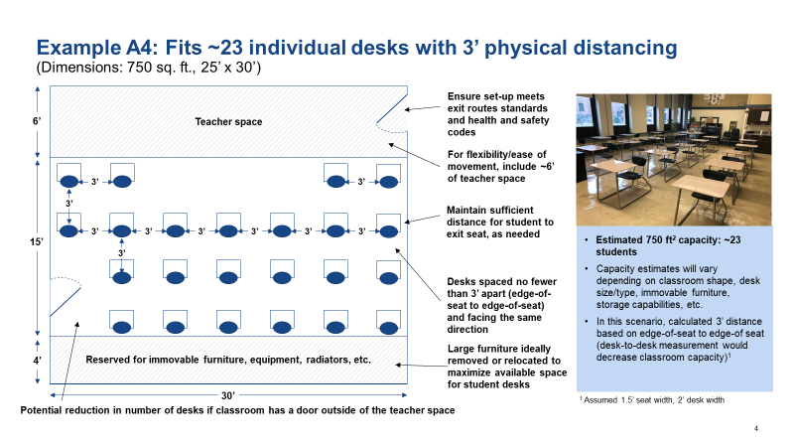

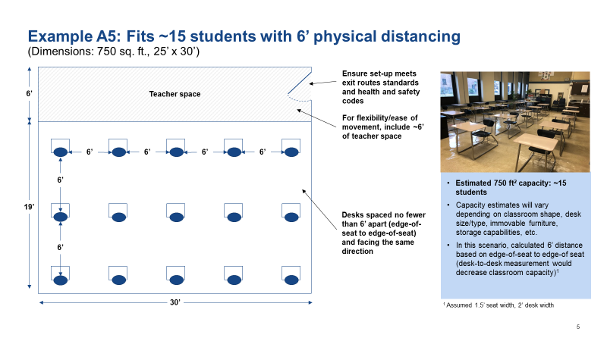

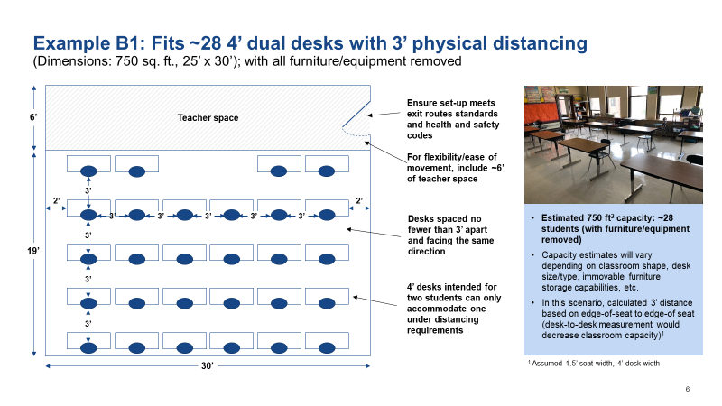

Ex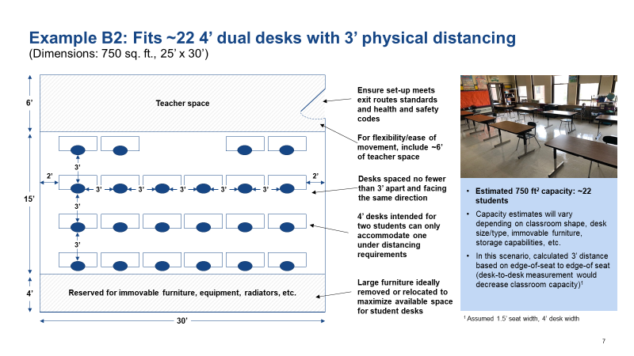
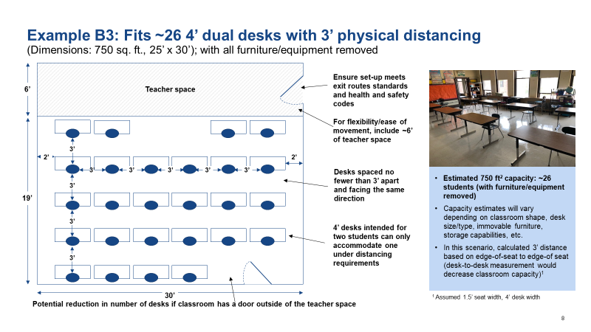

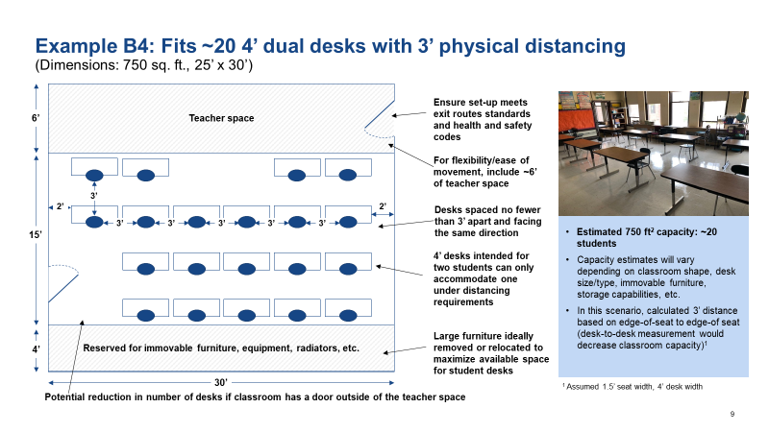

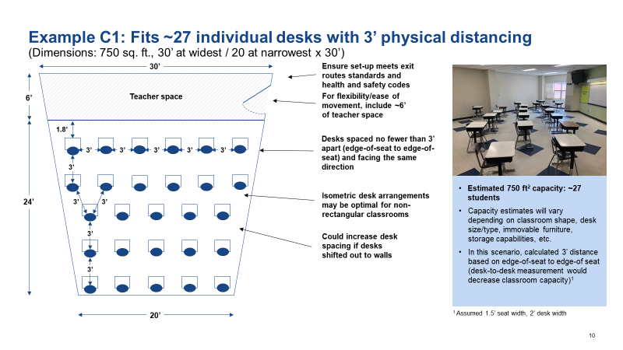

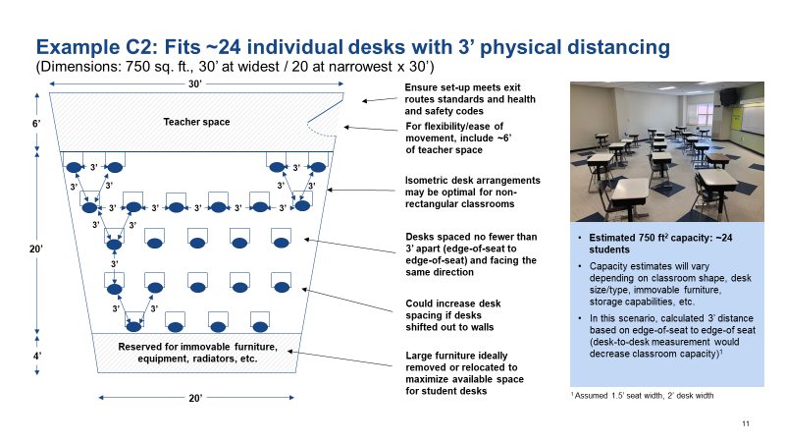

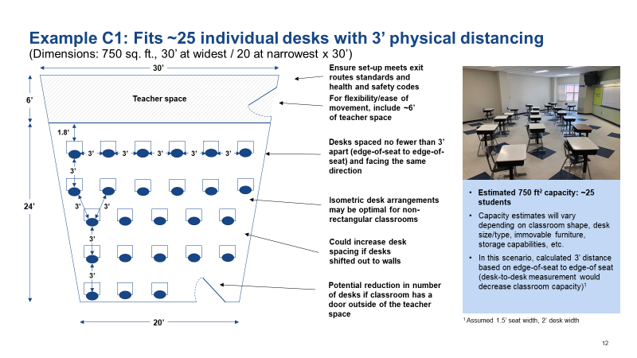

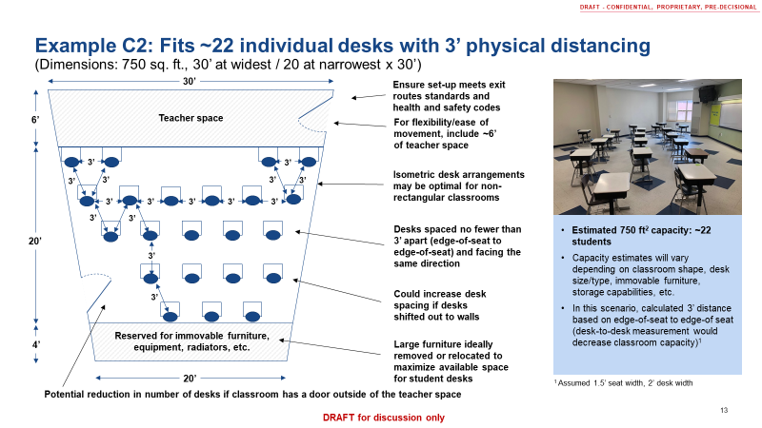

Appendix B: Laboratory seating

The diagrams below outline options for laboratory seating in order to maximize capacity while adhering to health and safety requirements. Use the following guidelines and considerations when developing laboratory seating layouts. Work closely with teachers and administrators to comply with fire and safety codes and adjust curriculums as necessary to accommodate capacity and physical changes.

Plexiglass barriers:
- Usage: Barriers should only be used in laboratory settings where desks are unable to be moved or cannot be replaced with moveable desks.
- Height: Barriers should be tall enough to extend beyond a student’s standing height
- Width: Barriers should extend at least one foot past the edge of the table and abide by fire and safety regulations
- Cleaning: Barriers should be properly cleaned between uses
- Rubber edges: Consider use of rubber edges to avoid risk of injury when plexiglass extends beyond tables
- Classroom protocols: Make sure that plexiglass barrier use is aligned to safety procedures and consider adjusting classroom experiments to avoid potential fire hazards

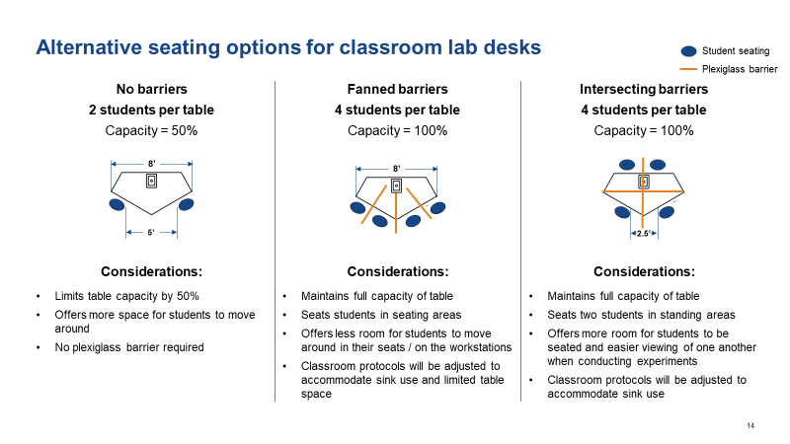

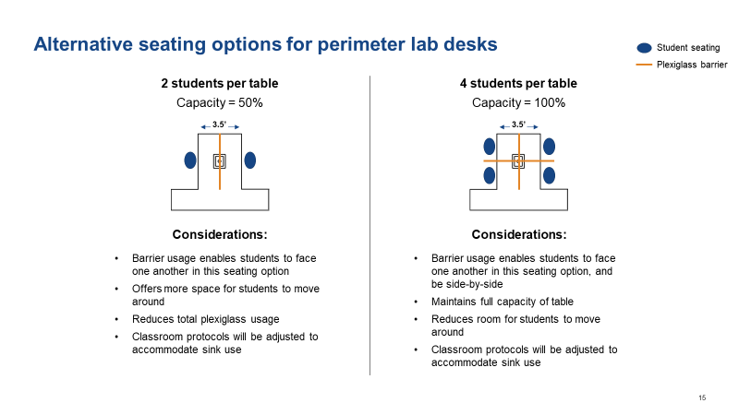

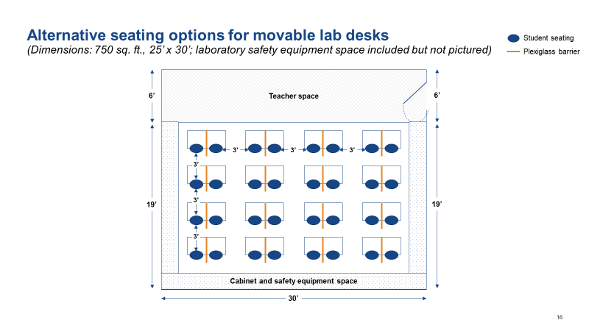

Appendix C: Cafeteria seating

The diagrams below outline options for cafeteria seating based on four common cafeteria tables. Use the following guidelines and considerations to determine the most feasible way to utilize cafeteria space (e.g., for classrooms or for eating). Work closely with facility departments to comply with fire and safety codes.

Considerations for plexiglass barriers:
- Usage: Barriers may be used to increase cafeteria capacity during meals.
- Height: Barriers should be tall enough to extend beyond a student’s standing height
- Width: Barriers should extend at least one foot past the edge of the table and abide by fire and safety regulations
- Cleaning: Barriers should be properly cleaned between uses
- Rubber edges: Consider use of rubber edges to avoid risk of injury when plexiglass extends beyond tables
- Classroom protocols: Make sure that plexiglass barrier use is aligned to safety procedures and consider adjusting classroom experiments to avoid potential fire hazards

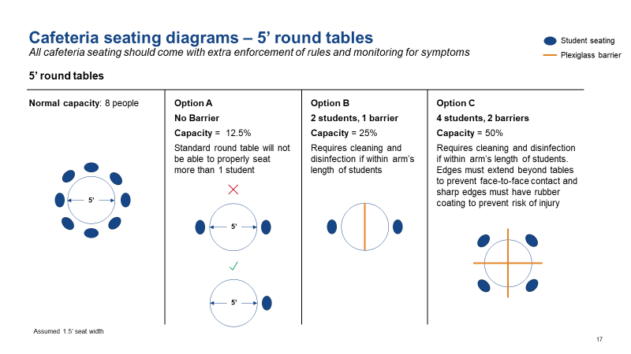
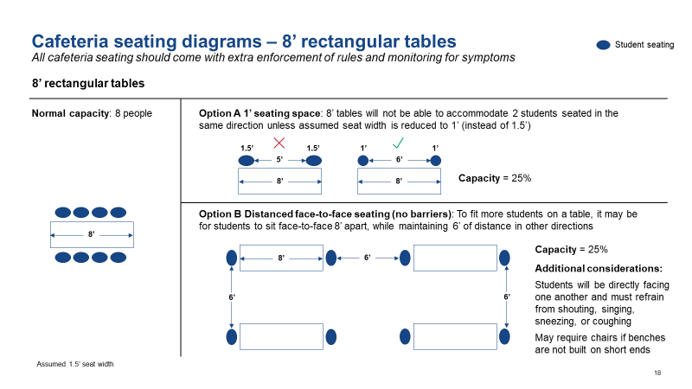
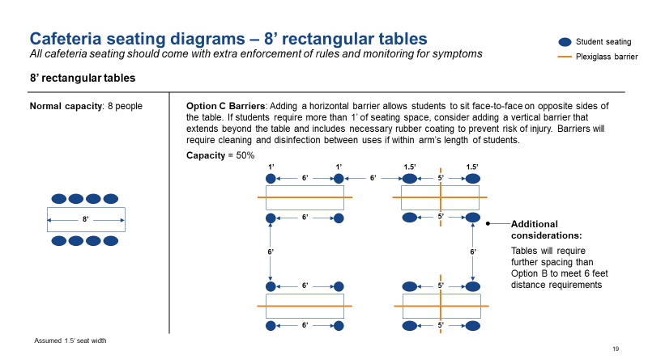

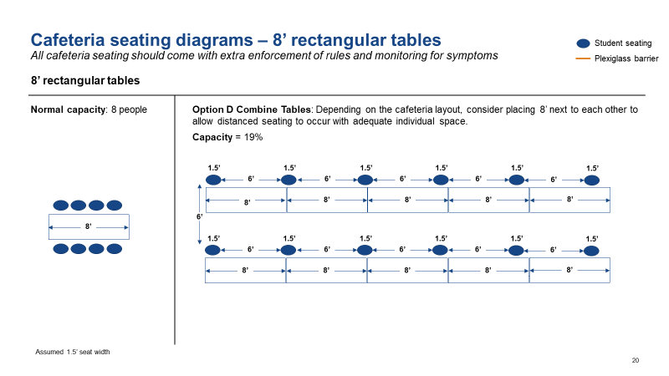

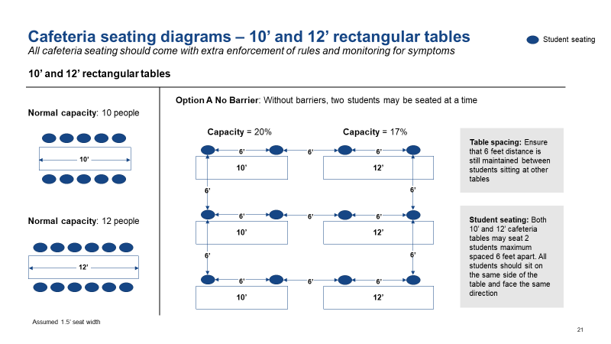
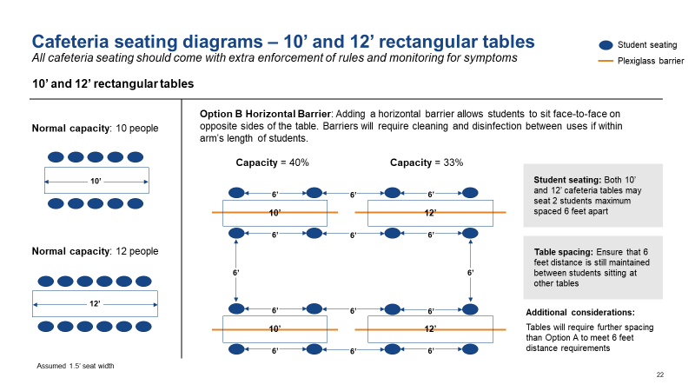
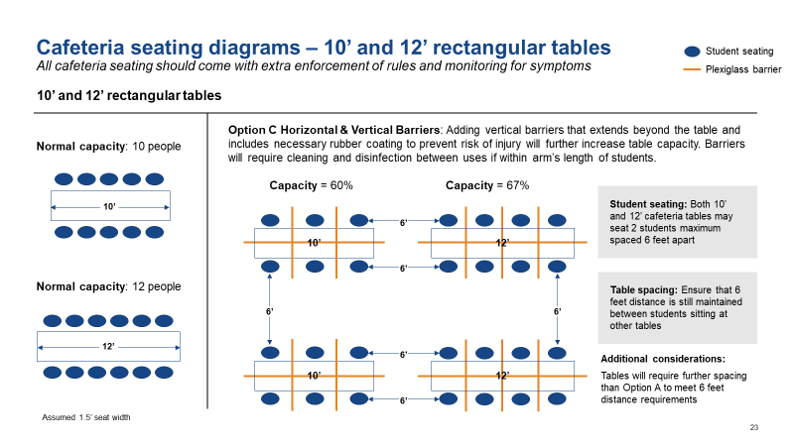

HSPH. (2020). Schools for Health: Risk Reductions Strategies for Reopening Schools. Available at https://schools.forhealth.org/wp-content/uploads/sites/19/2020/06/Harvard-Healthy-Buildings-Program-Schools-For-Health-Reopening-Covid19-June2020.pdf
https://learningpolicyinstitute.org/product/reopening-schools-covid-19-brief
CDC. (2020). Considerations for Schools. Available at https://www.cdc.gov/coronavirus/2019-ncov/community/schools-childcare/schools.html
HSPH. (2020). Schools for Health: Risk Reductions Strategies for Reopening Schools. Available at https://schools.forhealth.org/wp-content/uploads/sites/19/2020/06/Harvard-Healthy-Buildings-Program-Schools-For-Health-Reopening-Covid19-June2020.pdf
HSPH. (2020). Schools for Health: Risk Reductions Strategies for Reopening Schools. Available at https://schools.forhealth.org/wp-content/uploads/sites/19/2020/06/Harvard-Healthy-Buildings-Program-Schools-For-Health-Reopening-Covid19-June2020.pdf
CDC. (2020). Hand Hygiene Recommendations. Available at https://www.cdc.gov/coronavirus/2019-ncov/hcp/hand-hygiene.html
Kratzel, A., Todt, D., V'kovski, P., Steiner, S., Gultom, M., Thao, T. T. N., ... & Dijkman, R. (2020). Inactivation of severe acute respiratory syndrome coronavirus 2 by WHO-recommended hand rub formulations and alcohols. Emerg Infect Dis, 26. Available at https://wwwnc.cdc.gov/eid/article/26/7/20-0915_article
HSPH. (2020). Schools for Health: Risk Reductions Strategies for Reopening Schools. Available at https://schools.forhealth.org/wp-content/uploads/sites/19/2020/06/Harvard-Healthy-Buildings-Program-Schools-For-Health-Reopening-Covid19-June2020.pdf
HSPH. (2020). Schools for Health: Risk Reductions Strategies for Reopening Schools. Available at https://schools.forhealth.org/wp-content/uploads/sites/19/2020/06/Harvard-Healthy-Buildings-Program-Schools-For-Health-Reopening-Covid19-June2020.pdf
Massachusetts Commonwealth. (2020). Workplace COVID-19 Re-occupancy Guide. Available at https://files.constantcontact.com/d0791a30801/89460c55-52ba-4610-980e-00b268a613fa.pdf
Kimmitt, P.T. and Redway, K. R. (2016). Evaluation of the potential for virus dispersal during hand drying: a comparison of three method. Journal of Applied Microbiology, 2016/1655. Available at https://pubmed.ncbi.nlm.nih.gov/26618932/;
Best, E., Parnell, P., Couturier, J., Barbut, F., Le Bozec, A., Arnoldo, L., Madia, A., Brusaferro, S., and Wilcox, M.H. (2018). Environmental contamination of bacteria in hospital washrooms according to hand-drying method: a multi-centre study. Journal of Hospital Infection, 2018,100. Available at https://pubmed.ncbi.nlm.nih.gov/30006281/;
Best, E. L. and Redway, K. (2014). Comparison of different hand-drying methods: the potential for airborne microbe dispersal and contamination. Journal of Hospital Infection 2015/89. Available at https://pubmed.ncbi.nlm.nih.gov/25586988/
CDC. (2020). Considerations for Schools. Available at https://www.cdc.gov/coronavirus/2019-ncov/community/schools-childcare/schools.html
CDC (2020). How to clean and disinfect. Available at https://www.cdc.gov/coronavirus/2019-ncov/community/disinfecting-building-facility.html
Melnick, H., & Darling-Hammond, L. (with Leung, M., Yun, C., Schachner, A., Plasencia, S., & Ondrasek, N.). (2020). Reopening schools in the context of COVID-19: Health and safety guidelines from other countries (policy brief). Available at https://learningpolicyinstitute.org/product/reopening-schools-covid-19-brief
CDC. (2020). Considerations for Schools. Available at https://www.cdc.gov/coronavirus/2019-ncov/community/schools-childcare/schools.html
Melnick, H., & Darling-Hammond, L. (with Leung, M., Yun, C., Schachner, A., Plasencia, S., & Ondrasek, N.). (2020). Reopening schools in the context of COVID-19: Health and safety guidelines from other countries (policy brief). Available at https://learningpolicyinstitute.org/product/reopening-schools-covid-19-brief
Ren, S., Wang, W., Hao, Y. Zhang, H. Wang, Z., Chen, Y., Gao, Rong. (2020). Stability and infectivity of coronaviruses in inanimate environments. Available at https://www.wjgnet.com/2307-8960/full/v8/i8/1391.htm
CDC. (2020). Interim Guidance for Administrators of US K-12 Schools and Child Care Programs. Available at https://www.cdc.gov/coronavirus/2019-ncov/community/schools-childcare/guidance-for-schools.html
HSPH. (2020). Schools for Health: Risk Reductions Strategies for Reopening Schools. Available at https://schools.forhealth.org/wp-content/uploads/sites/19/2020/06/Harvard-Healthy-Buildings-Program-Schools-For-Health-Reopening-Covid19-June2020.pdf
HSPH. (2020). Schools for Health: Risk Reductions Strategies for Reopening Schools. Available at https://schools.forhealth.org/wp-content/uploads/sites/19/2020/06/Harvard-Healthy-Buildings-Program-Schools-For-Health-Reopening-Covid19-June2020.pdf
HSPH. (2020). Schools for Health: Risk Reductions Strategies for Reopening Schools. Available at https://schools.forhealth.org/wp-content/uploads/sites/19/2020/06/Harvard-Healthy-Buildings-Program-Schools-For-Health-Reopening-Covid19-June2020.pdf
HSPH. (2020). Schools for Health: Risk Reductions Strategies for Reopening Schools. Available at https://schools.forhealth.org/wp-content/uploads/sites/19/2020/06/Harvard-Healthy-Buildings-Program-Schools-For-Health-Reopening-Covid19-June2020.pdf

